
MATHEMATICS DEPARTMENT
Year 11 Specialist – 2016
Test Number 3:
Counting Techniques and Vector Applications
Resource Free
Total Mark
/47
Name: _________Solutions________________________ Teacher: DDA
Marks: 22
Time Allowed: 20 minutes
Weight: 5%
Instructions: You ARE NOT permitted any notes or calculator. Show your working where appropriate remembering you must show working for questions worth more than 2 marks.
_________________________________________________________________________
1 A product code consists of 4 characters, each of which may be the digits 1–9 or the letters A, B and C.
The number of possible product codes is
A 34 × 94
B 12 × 11 × 10 × 9
C 9P3
D 9C3
E 124

[1 mark]
2 A Year 8 student making course selections for Year 9 has the choices shown below:
Compulsory: English, Maths, Science and PE
Choice 1: Music, Art, History, Economics, Health, Business practices
Choice 2: Sewing, Cooking, Home Economics, Metalwork, Woodwork, Workshop
Choice 3: Geography, Computer Studies, French, German, Chinese
The number of different possible courses is:
A 184
B 720
6 x 6 x 5 = 180
C 180
D 252
E 216
[1 mark]
3 A family has 5 children. What is the probability of guessing the exact sequence of boys and girls in the family?
A
B
C
$$2^{5} possible sequences$$
$$∴\frac{1}{32} is the probability$$
D
E

[1 mark]
4 The 24 people on a bus have black, brown, red, blonde, grey, pink and green hair. Obviously some are dyed, but how many people must get off at the same stop for you to be sure that two of those who get off have the same hair colour?
A 7
Pigeon hole Principle
7 different colours. Need one more than this to ensure at least one double.
B 8
C 12
D 24
E 14
[1 mark]
5 The projection of m = (4, 60°) on n = (10, 240°) is:
A 4
B 10
m and n are in opposite directions (parallel)
$∴$ m projects wholly onto -n
C −4
D 0
E −10

[1 mark]
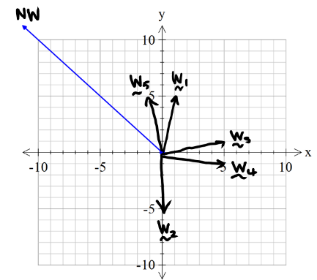
6 An airplane is flying toward the north-west. Which of the following wind velocity vectors, where i is east and j is north, increases the plane’s speed the most?
A w1 = i + 5j
B w2 = −5j
C w3 = 5i + j
D w4 = 5i − j
E w5 = −i + 5j
[1 mark]
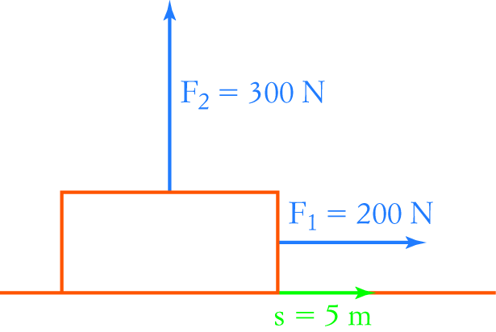
7 An object is subjected to two forces as shown in the diagram
on the right. If the object has a displacement of 5 m, then the
work done by the forces is:
A 1000 J
Only the 200N force has a component in the direction of the movement, so only that force does any work. W = 200 x 5
B 0
C 1500 J
D 2500 J
E 500 J [1 mark]

8 How many people do you need to be sure of having 3 with their birthday on the same day of the month?
They can be in different months.
Using the pigeonhole principle, the number needed = 31 + 31 + 1= 63

[2 marks]
9 The angle between vectors a and b is θ. Find a ⋅ b when:
|a| = 6, |b| = 10 and θ = 120°

a ⋅ b = |a| |b| cos (θ)
= 6 × 10 × cos (120°)
= – 30

[2 marks]
10 Calculate the scalar product of the following pair of vectors.
14i − 7j and 12i + 24j

(14i − 7j) ⋅ (12i + 24j)
= 14 × 12 + −7 × 24
= 0

[1 mark]
11 Determine if the following pairs of vectors are perpendicular, parallel or neither.
a (−4, −3) and (2, −7)
Vectors are neither parallel nor perpendicular.

b (−3, 1.5) and (6, −3)

The vectors are parallel (−2 × (−3, 1.5) = (6, −3))
c (5, 1) and (1, −5)
The vectors are perpendicular. ((5, 1) ⋅ (1, −5) = 5 × 1 + 1 × −5 = 5 + −5 = 0)

[3 marks]
12 A school theatre does not have any windows so that performances can use proper theatre lights during the day. During lunchtime rehearsal, all the lights go out while there are 10 people in the theatre.
As a result they come out at random. What is the probability that Andrew, Mona and Simone come out together, with Andrew between the two girls?
The number of ways the 10 people can come out = 10!
Considering Mona, Andrew and Simone as a group with 2 possible orders with Andrew in the middle,
the number of ways them coming out = 8! × 2

Probability of Mary being between David and Peter = $\frac{8!×2}{10!}$
= $\frac{2}{10×9}$ = $\frac{1}{45}$
[3 marks]
13 Prove that n! can be obtained from the alternative recursive rule that n! = (n − 1)[(n − 1)! + (n − 2)!],
where 0! = 1! = 1.
RTP: n! = (n − 1)[(n − 1)! + (n − 2)!]
RHS = (n − 1)[(n − 1)! + (n − 2)!] (start with more complex side)
= (n − 1)(n − 1)! + (n − 1)(n − 2)!
= (n − 1)(n − 1)! + (n − 1)!
= (n − 1 + 1)(n − 1)!
= n(n − 1)!
= n!
= LHS QED

[4 marks]


MATHEMATICS DEPARTMENT
Year 11 Specialist – 2016
Test Number 3:
Counting Techniques and Vector Applications
Resource Rich Section

Name: ______Solutions________________________ Teacher: DDA
Marks: 25
Time Allowed: 25 minutes
Weight: 5%
Instructions: 1 A4 page of notes allowed. Calculators allowed. Show your working where appropriate remembering you must show working for questions worth more than 2 marks.
_________________________________________________________________________
14 How many different anagrams of the word EXCESSIVE are there?
A 30 240

B 362 880
C 60 480
D 40 320
E 90 720

[1 mark]
15 In how many different ways can 8 different people be arranged in a circle?
A 20 160
B 10 080
Circular permutations of n things = (n − 1)!
Circular permutations of 8 people = 7!
C 362 880
D 5040
E 40 320

[1 mark]

16 How many 4 letter ‘words’ can be made from the letters of ENDORSE at least one letter must be a vowel. Three vowels are not allowed, and no letters may be used more than the number of times they appear in ENDORSE.
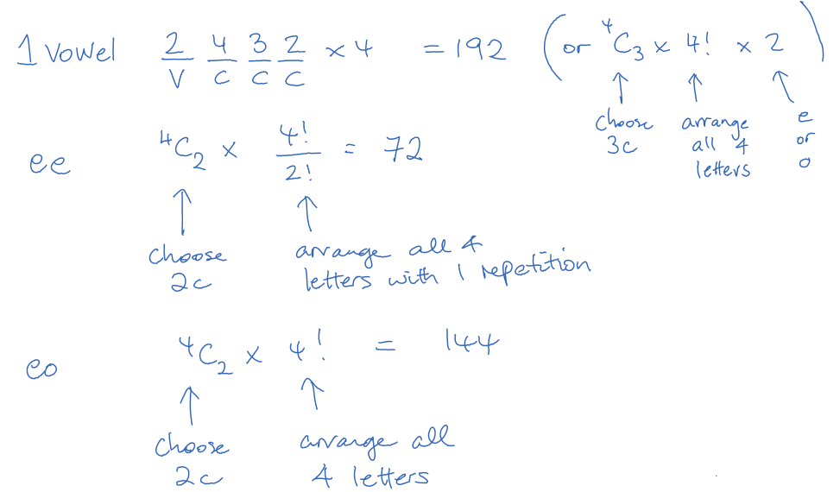
Total number of words = 192 + 144 + 72 = 408 [4 marks]

Alternate working:
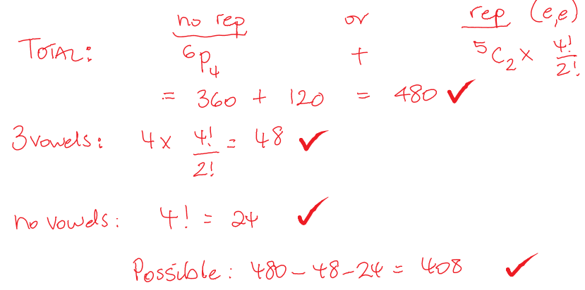

17 Calculate the angle between (2, 4) and (−7.5, 12).
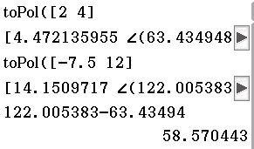
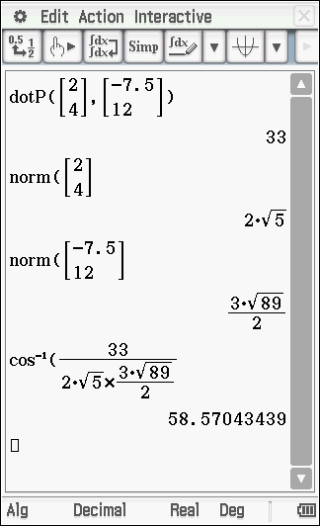
cos (θ) =
a ⋅ b = 2 × −7.5 + 4 × 12 = 33
|a| =
|b| =

cos (θ) =
θ≈ 58.6°
[3 marks]

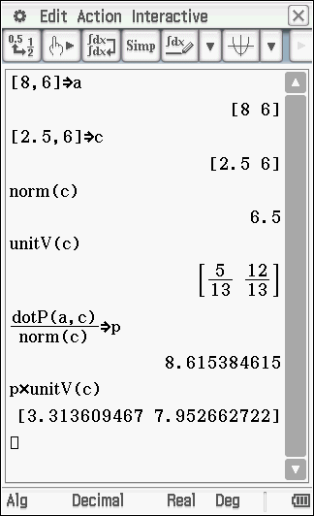
18 Find the projection of p = (8, 6) on q = (2.5, 6).
= = =

Projection of p on q is p ⋅ = [(8, 6) ⋅ =
= 8.6153…

Alternate working;

$$p=p∙\hat{q}$$
$$=\frac{p∙q}{\left|q\right|}$$
$$=\frac{56}{6.5}$$
$$≈8.62$$

[3 marks]
19 Calculate the work done in each of the following situations.
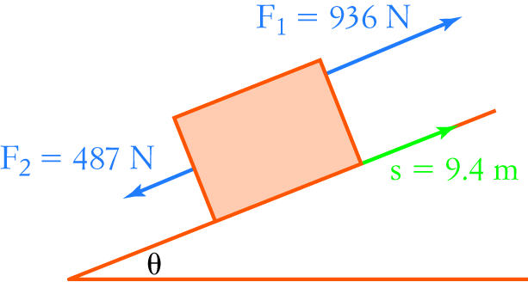
$$W=F.s$$
$$=(936-487)×9.4×\cos{0}$$
$$=4220.6J$$
[2 marks]
20 A car going up a hill inclined at 15° has a weight of 7800 N acting vertically downwards.
Resolve the weight into components parallel and perpendicular to the slope.
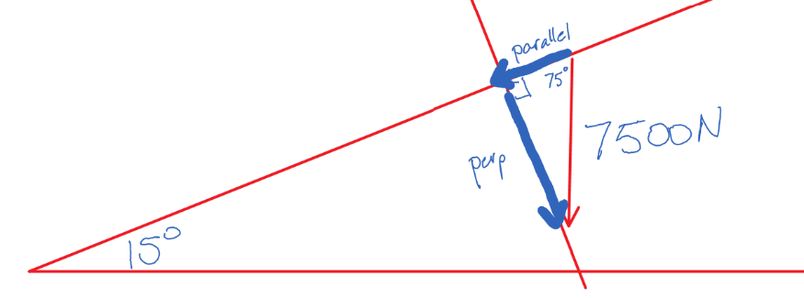

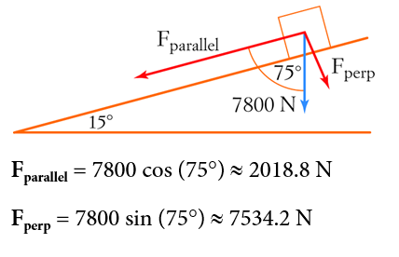
[3 marks]
21 A yacht makes 12 knots ‘through the water’ and sails at a bearing of 242°. There is a strong current of 5 knots towards the south. What are the actual bearing and speed of the yacht?
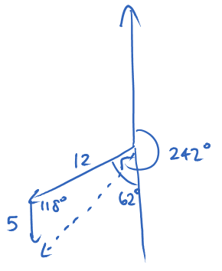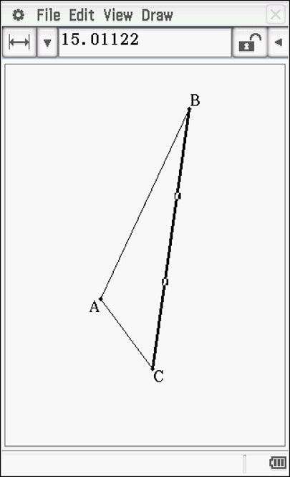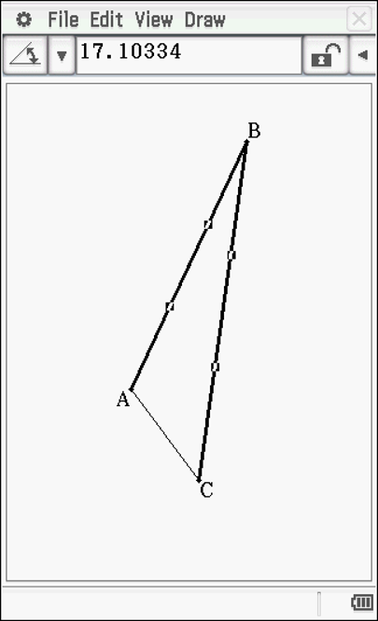
242 – 17.2 = 224.9
The actual speed and bearing of the yacht is about 15.0 knots at a bearing of 224.9°.

[4 marks]
22 Three ropes attached to a metal ring are being pulled by different people. Lucy is exerting a force of 200 N, and Gary is exerting a force of 250 N at an angle of 150° to Lucy. What force must Penelope be exerting if the ring does not move?
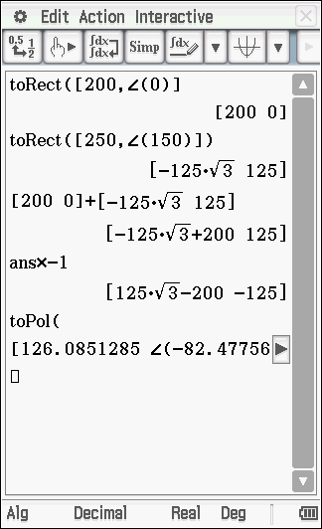

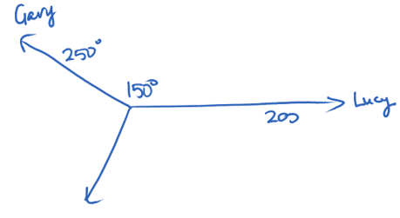

Penelope’s force is about 126 N at an angle of 82.5° to Lucy, and 127.5° to Gary.

[4 marks]

